8.Perform basic Image Handling and processing operations on the image is to read an image in python and Dilate an Image using Dilate function

**AIM:**

To read an image and convert it to grayscale using OpenCV in Python.

**PROCEDURE:**

1. Install OpenCV (if not already installed):install opencv-python
2. Import required libraries
3. Read the image
4. Convert the image to grayscale
5. Display the images
6. Wait for a key press & close windows

**PROGRAM:**

import cv2

image = cv2.imread("sample.jpg") # Replace 'sample.jpg' with your image path

gray_image = cv2.cvtColor(image, cv2.COLOR_BGR2GRAY)

cv2.imshow("Original Image", image)

cv2.imshow("Grayscale Image", gray_image)

cv2.waitKey(0)

cv2.destroyAllWindows()

**INPUT:**

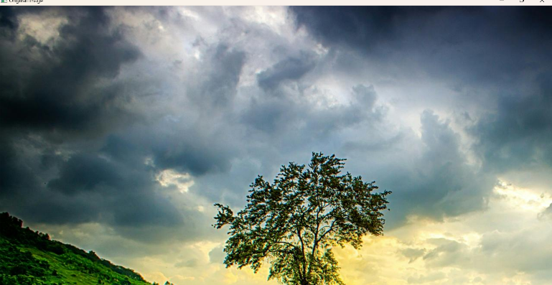

**OUTPUT:**

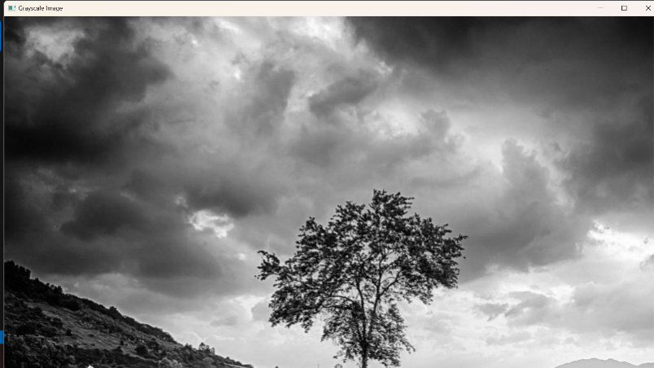

**RESULT :**

Successfully read the input image and converted it to grayscale using OpenCV in Python.